Project 1

Game title.

Hi-Ho! Cherry-O

Course

CIS-5

Due Date

10/25/13

Author

Alexander Nikola Wickes

The Official “Hi-Ho! Cherry-O” instruction guide.

The Hi-Ho! Cherry-O computer program is completely based off of the board game by Hasbro.



Direct link.

<http://www.hasbro.com/common/instruct/Hi_Ho_Cherry_O_2006.pdf>

Flow Chart included in Email

And attacthed in submissison.

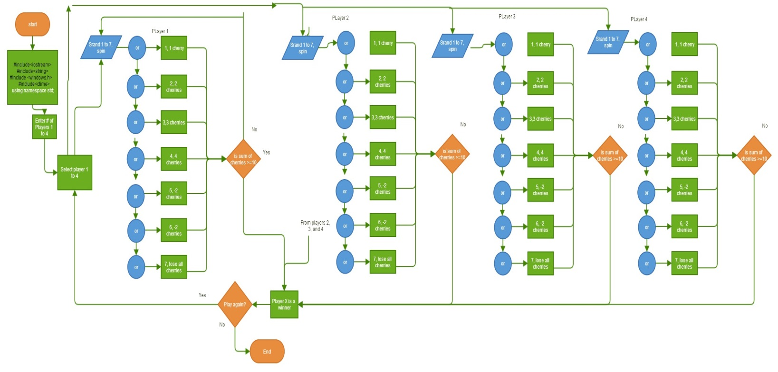

Program

//Wickes, Alexander, 1st game project, 10/25/13

//Hl HO! CHERRY-O® gameboard with spinner

//4 Different-colored buckets, 40 Cherries

//Object:To be the first player to pick 10 cherries from your tree and fill your bucket.

//Assembly and Setup

//1. Assemble the spinner as shown below.

//A. Break out the arrow and spinner base.

//B. Insert base through hole as shown.

//C. Snap together arrow and spinner base.

//2. Each player chooses a tree and places 10 cherries on it.

//3. The youngest player goes first. Play passes to the left.

//Game Play

//In turn, each player spins and plays according to his/her spin:

//One Cherry:Pick one cherry from your tree and put it into your bucket.

//Two Cherries: Pick two cherries from your tree and put them into your bucket.

//Three Cherries: Pick three cherries from your tree and put them into your bucket.

//Four Cherries:Pick four cherries from your tree and put them into your bucket.

//Bird or Dog:Take two cherries from your bucket and place them back on

//your tree. (If you have only one cherry, put that one back. If you have

//none do nothing.)

//Spilled Bucket:Dump the cherries out of your bucket, place them back on your

//tree and start over.

//Winning:You win if you're the first player to call, "Hi Ho! CherryO!" indicating

//that you have 10 cherries in your bucket.

#include<iostream>

#include<string>

#include <windows.h> //needed for sleep functions

#include<ctime> //time for random number generator

using namespace std;

void Spin(int&); // function spin

void Spin(int& spinner)//before spin

{

srand(time(NULL));// after spin

spinner=rand()%7+1;//random number between 1 and 7 like game spinner

}

int main()

{

char again;// play again

do{ //do / while to play another game

string anykey; //press any key to spin

int cherry[4];// player buckets

int i=0;

int winner, num, spinner;//keep running until a winner, define number of players

//and random number of 1 to 7 for spinner

cout<<"Welcome to Hi Ho! CherryO!"<<endl;

Sleep(3000); // 3 sec in milliseconds 1Sec = 1000 MiliSeconds, from window lib

cout<<"Up to 4 players!"<<endl;

Sleep(3000); // 3 sec in milliseconds 1Sec = 1000 MiliSeconds, from window lib

cout<<"Lets Play "<<endl;

Sleep(3000); // 3 sec in milliseconds 1Sec = 1000 MiliSeconds, from window lib

system("CLS");//cout << string(50, '\n'); //clear the screen

// "win" decides whether the program should continue or not

// \*\*string answer; // "answer" has the user input something to continue

cout<<"Enter the number of players (2 to 4)."<<endl;

cin>>num;

//start with 0 cherrys to begin with

for (i=0;i<num+1;i++){

cherry[i]=0;

}

cout<<"All cherry buckets are currently empty."<<endl;

winner=1;

//keep the loop going until there is a winner

while(winner==1)

{// give each player a turn

for (i=1;i<=num;i++)

{ //end the game if there is a winner

if (cherry[1]<10||cherry[2]<10||cherry[3]<10||cherry[4]<10)//run until

//there is a winner

{

cout<<"Player "<<i<<" type press anykey and enter to spin."<<endl;

cin>>anykey; //anykey to spin

Spin(spinner);//call spin function

cherry[i]=cherry[i]+spinner;//add cherrries to bucket

cout<<"Player "<<i<<" spun a "<<spinner<<". "<<endl;// spin results

cout<<" "<<endl; //row

if(cherry[i]>10)

{

cherry[i]=10;

}

cout<<" "<<endl; //row

// 7 if's for 7 positions on the spinner per game instructions above

if (cherry[i]==1){

cout<<"Pick one cherry from your tree and put it into your bucket."<<endl;

cherry[i]=1;

}

else if (cherry[i]==2){

cout<<"Pick two cherries from your tree and put them into your bucket."<<endl;

cherry[i]=2;

}

else if (cherry[i]==3){

cout<<"Pick three cherries from your tree and put them into your bucket."<<endl;

cherry[i]=3;

}

else if (cherry[i]==4){

cout<<"Pick four cherries from your tree and put them into your bucket."<<endl;

cherry[i]=4;

}

else if (cherry[i]==5){

cout<<"A bird took two cherries from your bucket and placed them back on the tree."<<endl;

cherry[i]=-2;}

else if (cherry[i]==6){

cout<<"A dog took two cherries from your bucket and placed them back on the tree."<<endl;

cherry[i]=-2;

}

else if (cherry[i]==7){

cout<<"Your bucket was knocked over. All your cherrys go back to the tree."<<endl;

cherry[i]=0;

}

cout<<" "<<endl; //row

//tell players what contents are in the bucket

cout<<"You now have "<<cherry[i]<<" cherries in your bucket."<<endl;

if (cherry[i]>=10){ // tell a play when they win, yell Hi ho CherryO!

cout<<"Player "<<i<<" Hi Ho! CherryO!"<<endl;

Sleep(500); // 1/2 sec in milliseconds 1Sec = 1000 MiliSeconds, from window lib

cout<<"Your a winner!"<<endl;

winner=2;

}

if (cherry[i]>=10){

cherry[i]=10;

}}}} //end if, for, while

cout<<" \n"; //row

cout << "Would you like to try again?(y/n)\n";// play again?

cin >> again;

} while (again =='y' || again =='Y');

cout << "good-bye\n";

return 0;

}